**Data communication and computer networks Lab**

**Semester:6th**



**Lab Report # 5**

**Submitted By:** *Zainab Khalid*

**Registration No:***19PWCSE1743*

**Section: A**

**Submitted to:** *Engr Faiz Ullah*

**Department of Computer Systems Engineering**

**University of Engineering and Technology Peshawar**

**CSE 303L: Data Communication and Computer Networks**

|  |  |  |  |  |
| --- | --- | --- | --- | --- |
| **Demonstration of Concepts** | **Poor (Does not meet expectation (1))**  The student failed to demonstrate a clear understanding of the assignment concepts | **Fair (Meet Expectation (2-3))**  The student demonstrated a clear understanding of some of the assignment concepts | **Good (Exceeds Expectation (4-5)**  The student demonstrated a clear understanding of the assignment concepts | **Score**  **30%** |
| **Accuracy** | The student mis-configured enough network settings that the lab computer couldn't function properly on the network | The student configured enough network settings that the lab computer partially functioned on the network | The student configured the network settings that the lab computer fully functioned on the network | **30%** |
| **Following Directions** | The student clearly failed to follow the verbal and written instructions to successfully complete the lab | The student failed to follow the some of the verbal and written instructions to successfully complete all requirements of the lab | The student followed the verbal and written instructions to successfully complete requirements of the lab | **20%** |
| **Time Utilization** | The student failed to complete even part of the lab in the allotted amount of time | The student failed to complete the entire lab in the allotted amount of time | The student completed the lab in its entirety in the allotted amount of time | **20%** |

**Credit Hours: 1**

**Wireshark DHCP :**

* In this lab, we’ll take a **quick look at DHCP**. Recall that DHCP is used extensively in corporate, university and home-network wired and wireless LANs to dynamically assign IP addresses to hosts (as well as to configure other network configuration information).

This lab is brief, as we’ll only examine the DHCP packets captured by a host. If you also

have administrative access to your DHCP server, you may want to repeat this lab after

making some configuration changes (such as the lease time). If you have a router at

home, you most likely can configure your DHCP server. Because many Linux/Unix

machines (especially those that serve many users) have a static IP address and because manipulating DHCP on such machines typically requires super-user privileges, we’ll only present a Windows version of this lab below.

Dynamic Host Configuration Protocol v4 (DHCPv4) assigns IPv4 addresses and other network configuration information dynamically. Because desktop clients typically make up the bulk of network nodes, DHCPv4 is an extremely useful and timesaving tool for network administrators.

The DHCPv4 server dynamically assigns, or leases, an IPv4 address from a pool of addresses for a limited period of time chosen by the server, or until the client no longer needs the address.

Clients lease the information from the server for an administratively defined period. Administrators configure DHCPv4 servers to set the leases to time out at different intervals. The lease is typically anywhere from 24 hours to a week or more. When the lease expires, the client must ask for another address, although the client is typically reassigned the same address.

DHCPv4 works in a client/server mode. When a client communicates with a DHCPv4 server, the server assigns or leases an IPv4 address to that client.

* The client connects to the network with that leased IPv4 address until the lease expires. The client must contact the DHCP server periodically to extend the lease.
* This lease mechanism ensures that clients that move or power off do not keep addresses that they no longer need.
* When a lease expires, the DHCP server returns the address to the pool where it can be reallocated as necessary.

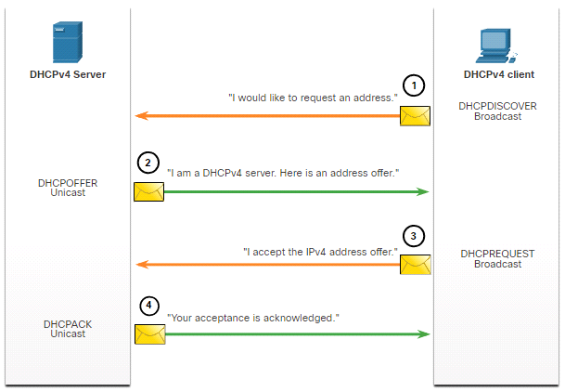

**DHCP Experiment:**

In order to observe DHCP in action, we’ll perform several DHCP-related commands and

capture the *DHCP messages* exchanged as a result of executing these commands. Do the following:

1. Begin by opening the Windows Command Prompt application (which can be found in your Accessories folder). As shown in Figure 1, enter **“*ipconfig /release*”.** The executable for *ipconfig* is in C:\windows\system32. This command releases your current IP address, so that your host’s IP address becomes 0.0.0.0.

2. Start up the Wireshark packet sniffer, as described in the introductory Wireshark

lab and begin Wireshark packet capture.

3. Now go back to the Windows Command Prompt and enter “*ipconfig /renew*”.

This instructs your host to obtain a network configuration, including a new IP address. In Figure 1, the host obtains the IP address 192.168.1.101

4. Wait until the “ipconfig /renew” has terminated. Then enter the same command

“ipconfig /renew” again.

5. When the second “ipconfig /renew” terminates, enter the command

“ipconfig/release” to release the previously-allocated IP address to your computer.

6. Finally, enter “ipconfig /renew” to again be allocated an IP address for your computer.

7. Stop Wireshark packet capture.

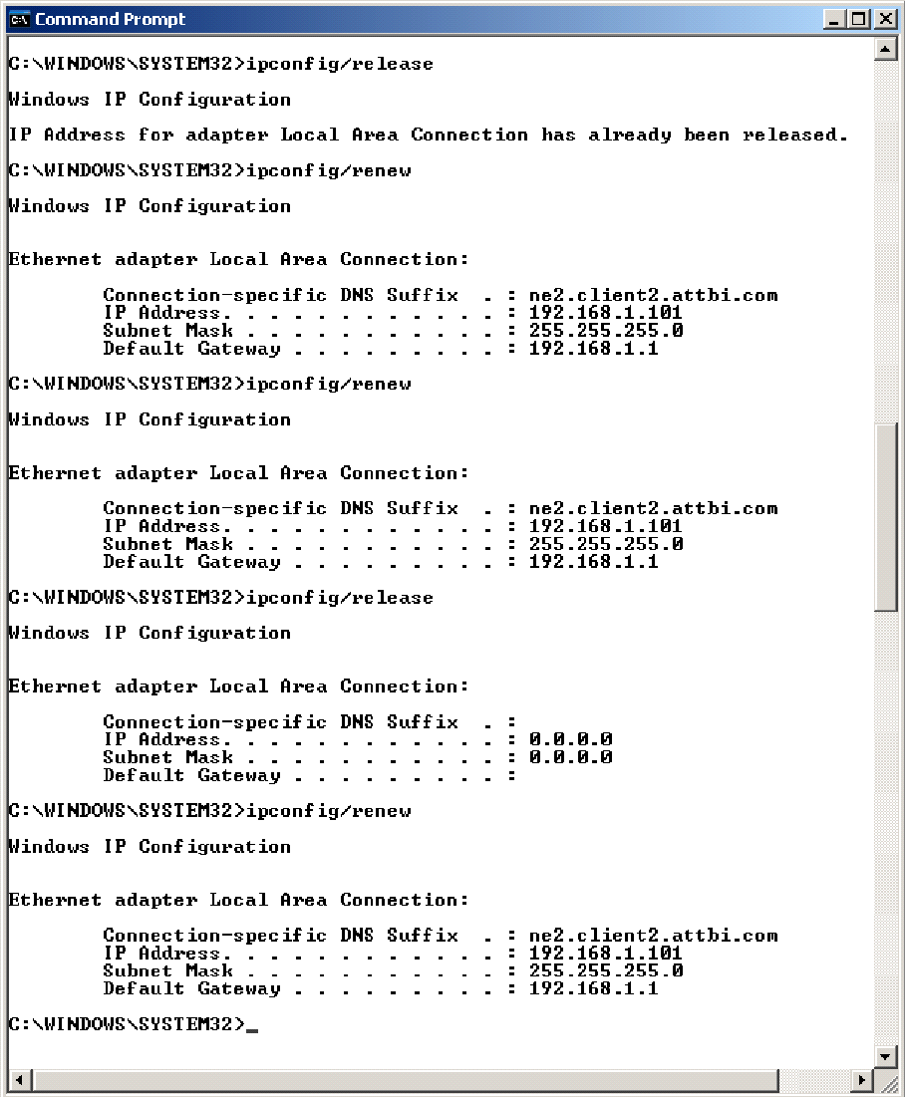

**Figure 1** Command Prompt window showing sequence of *ipconfig* commands that you should enter.

Now let’s take a look at the resulting Wireshark window. To see only the DHCP packets,

enter into the filter field “bootp”. (DHCP derives from an older protocol called BOOTP.

Both BOOTP and DHCP use the same port numbers, 67 and 68. To see DHCP packets in the current version of Wireshark, you need to enter “dhcp” in the filter.)

We see from Figure 2 that the first *ipconfig* renew command caused four DHCP packets

to be generated: ***a DHCP Discover packet, a DHCP Offer packet, a DHCP Request***

***packet, and a DHCP ACK packet.***

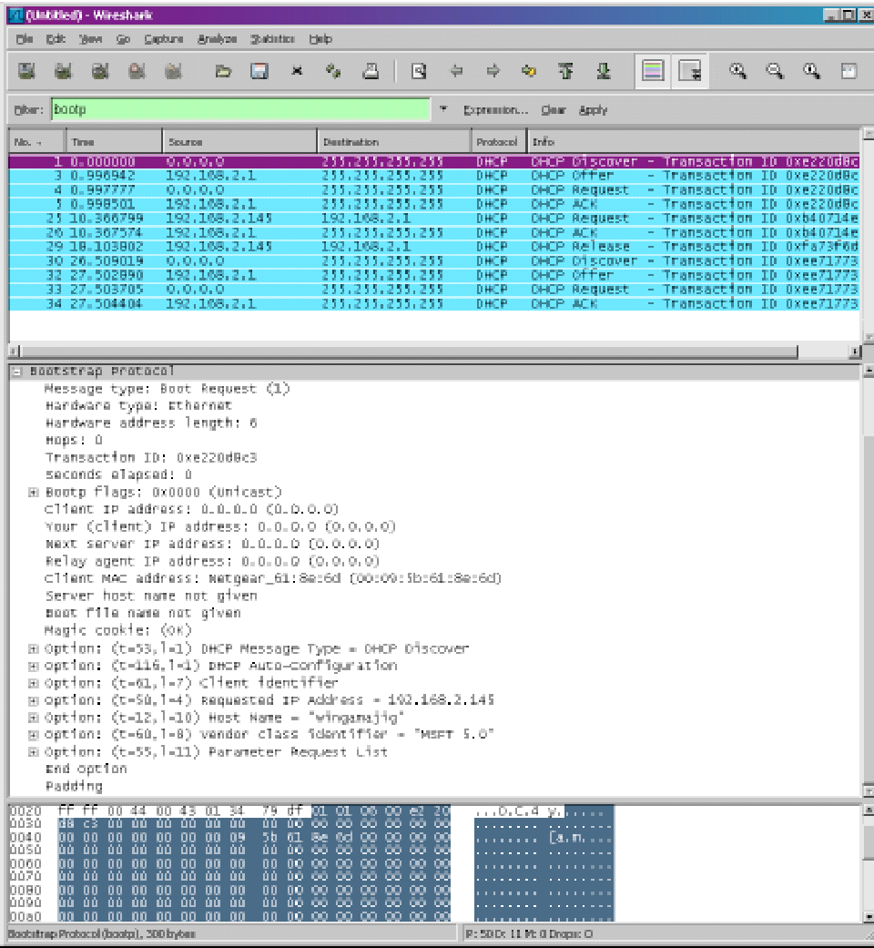

**Figure 2** Wireshark windows with first DHCP packet – the DHCP Discover packet –

expanded.

**What to Hand In:**

You should hand in a screen shot of the Command Prompt window similar to Figure 1 above. Whenever possible, when answering a question below, you should hand in a printout of the packet(s) within the trace that you used to answer the question asked.

Annotate the printout3 to explain your answer. To print a packet, use File->Print, choose

Selected packet only, choose Packet summary line, and select the minimum amount of packet detail that you need to answer the question.

Answer the following questions:

**Question: 1:**

Are DHCP messages sent over UDP or TCP?

**Answer:**

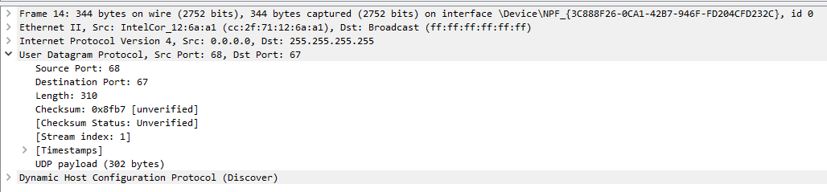

**They are sent over UDP.**

**Question:2**

2. Draw a timing datagram illustrating the sequence of the first four-packet

Discover/Offer/Request/ACK DHCP exchange between the client and server. For

each packet, indicated the source and destination port numbers. Are the port

numbers the same as in the example given in this lab assignment?

**Answer:**

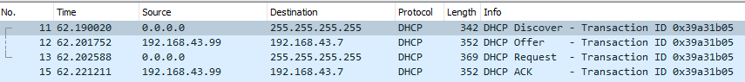

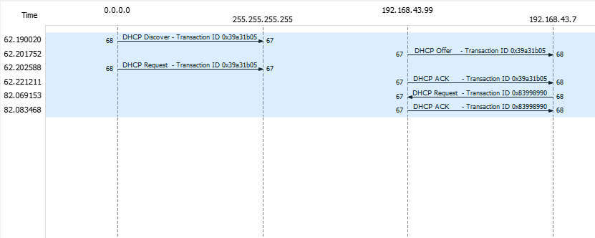

No the port numbers are not same, the DHCP server has the port number 67

And the DHCP client has the port number 68.

**Question:3**

What is the link-layer (e.g., Ethernet) address of your host?

**Answer:**



Host IP address=**cc:2f:71:12:6a:a1**

**Question:4**

4. What values in the DHCP discover message differentiate this message from the DHCP request message?

**Answer:**

**Discover Message:**

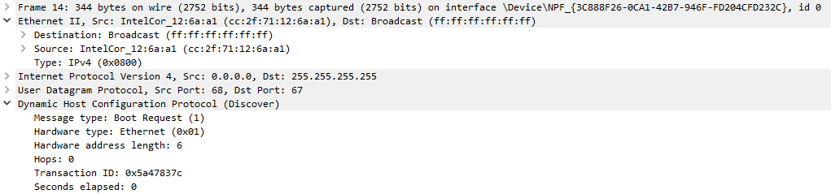

**Request Message:**

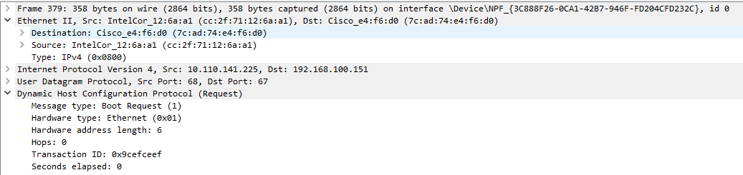

**Question:5**

What is the value of the Transaction-ID in each of the first four (Discover/Offer/Request/ACK) DHCP messages? What are the values of the Transaction-ID in the second set (Request/ACK) set of DHCP messages? What is the purpose of the Transaction-ID field?

**Answer:**

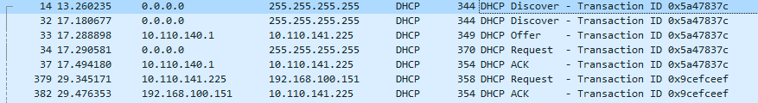

**DHCP messages along with their Transaction IDs.**

**Question:7**

What is the IP address of your DHCP server?

**Answer:**

DHCP server IP= 192.168.100.151

**Question:8**

What IP address is the DHCP server offering to your host in the DHCP Offer message? Indicate which DHCP message contains the offered DHCP address.

**Answer:**

The IP address offered by the DHCP server in the Offer message is: 192.168.100.247

**Question:9**

Explain the purpose of the router and subnet mask lines in the DHCP offer

message.

**Answer:**

The subnet mask line tells the client which subnet mask should be used.

**Question:10**

Explain the purpose of the lease time. How long is the lease time in your experiment?

**Answer:**

The purpose of lease time is to assign the IP address to the host at a specific time.

**Question:11**

What is the purpose of the DHCP release message? Does the DHCP server issue

an acknowledgment of receipt of the client’s DHCP request? What would happen if the client’s DHCP release message is lost?

**Answer:**

The DHCP release message is sent by the client to cancel the lease on an IP address given to it by the DHCP server.